May Block of the Month - Vase of Flowers
12” Block
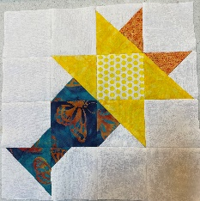

This block is made up of 16 three inch finished squares. 9 are just plain squares, 1 is a Half Square Triangle Unit, 2 have one corner “snowballed”, and 4 are combination units ( the instructions and pictures are below) . I have also included the original picture and measurements at the end in case you would like to work from there.
Plain Squares – Cut 3 ½” squares:
7 - background
1 - Vase Color
1 – center of flower
Half Square Triangle Unit – Cut 4” squares:
1 – background
1 – vase color
Snowballed Squares - Cut 3 ½” squares :
2 – Background
Cut 1 7/8” squares :
2 – vase color **Draw one diagonal line on the wrong
side of each square. This will be your actual sewing line.
Combination Units – Cut 4 ½” squares:
2 – background
1 – vase color
1 – darker flower color
2 – medium flower color

Directions:

- Make the HST Unit however you like. I draw two diagonal lines ¼” from each side of the diagonal line and sew just inside both. Then I trim it to the actual size of 3 ½”. This is placed at the bottom of the vase.
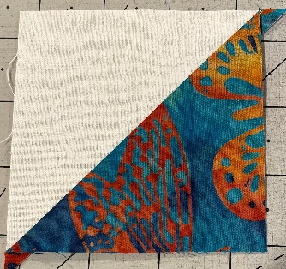

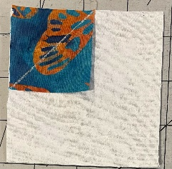
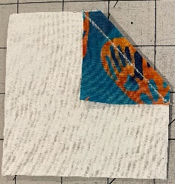
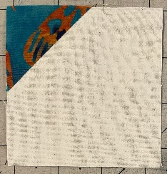
2. Make the snowball units by placing the small vase color square in one corner of the
background square and stitch on the line drawn on the diagonal. Trim seam to ¼” and
press to small triangle.
3. Make the two pairs of combination units. They will be mirror images. To start, make
HST units from one background with one vase color and one background with the dark
flower color. DO NOT TRIM the HST’s. You will have one of each HST left over that you
won’t need.
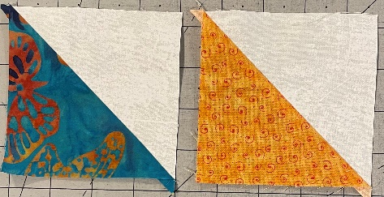

Now place each HST unit on top of the medium flower 4 ½” square and draw a line across the
seam ¼” away from both sides of the diagonal. Stitch just inside each line, cut apart between
the sewn lines and press toward the large triangle. You will have mirror images of both.
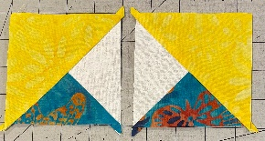
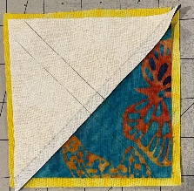
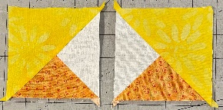
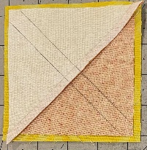

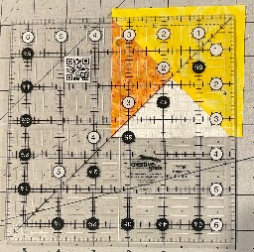
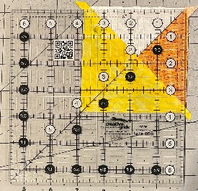
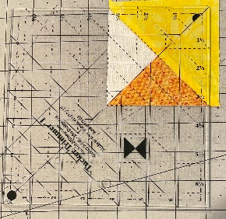
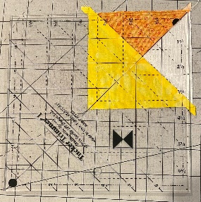
Trim to 3 ½”. If you have a Tucker Trimmer 1, trimming will be a breeze. I have also included
pictures of a Creative Grids ruler trim up as well. Enlarge the photo to see where the lines are.
Tucker Trimmer
Creative Grids

4. Lay out the squares as shown in the picture above and stitch together. I pressed the seams open
to cut down on the bulk. You are FINISHED!!!!!
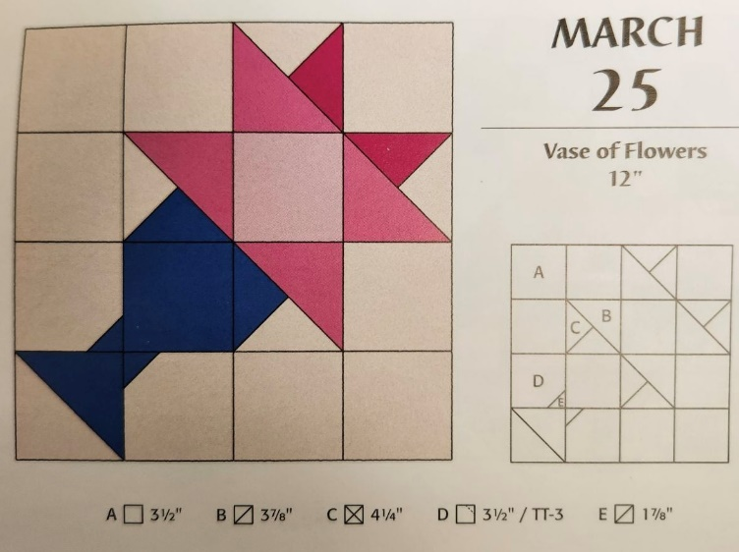
This is the original calendar pattern.

